Wireshark Network Capture Demonstration

Ryan Scott

Grand Canyon University  
ITT-306 Information Security II

Prof. Christine Bakke

## Login Result Success

## 

## 

## 

## Login Result Fail

## 

## Wireshark Login Capture Results

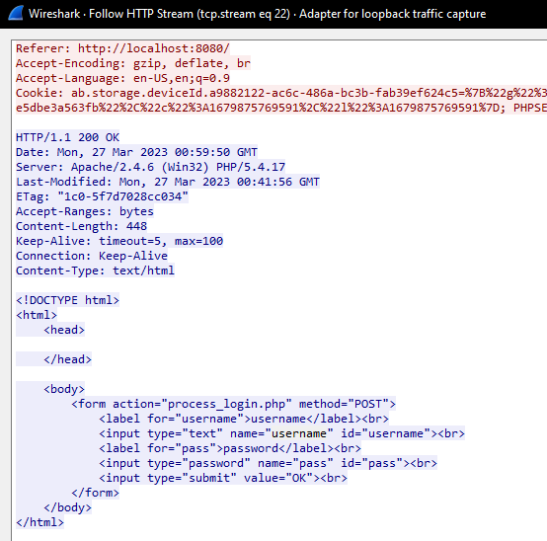

## Found the Username and Password!

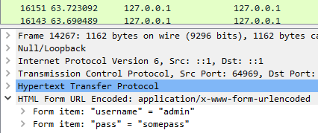

| **Protocol Initilials** | **Full Name** | **Purpose** | **Type of Application Likely to Utilize the Protocol** | **Security Vulnerability to Wireshark** |
| --- | --- | --- | --- | --- |
| SMTP | Simple Mail Transfer Protocol | Responsible for sending and receiving email messages. | Email clients such as Gmail or Outlook to send messages. | Yes |
| IMAP | Internet Message Access Protocol | Enables email clients to synchronize email messages across multiple devices. | Email clients such as Gmail or Outlook to access messages. | Yes |
| DNS | Domain Name System | Translates human-readable domain names (such as google.com) to IP addresses that computers can understand. | Web browsers, email clients, and other networked applications use DNS to resolve domain names to IP addresses. | Yes |
| SSH | Secure Shell | Encrypts all data transmitted between the client and server, including login credentials and commands. | System administrators and developers use SSH to remotely access and manage servers and other networked devices. | No |
| POP | Post Office Protocol | Downloads email messages from the server to the client's device and deletes them from the server. | Email clients such as Gmail or Outlook to download email messages from a remote email server. | Yes |
| FTP | File Transfer Protocol | Provides a standard way to send and receive files between different computers and servers. | Web developers and content managers use FTP to upload and download files to and from web servers. | Yes |
| TELNET | Telnet Protocol | Provides a way to remotely access and control computers as if you were sitting in front of them. | System administrators and network engineers perform remote management and troubleshooting of servers, switches, and routers. | Yes |

# References

Wikipedia contributors. (2023, March 10). *Application layer*. Wikipedia. <https://en.wikipedia.org/wiki/Application_layer>